OAuth 2.0

OAuth 2.0 is an authorization framework that allows third-party applications to access a user's data or resources without exposing their credentials. For accessing user data, users don’t have to share passwords with your app. Instead, using OAuth 2.0 you obtain an "access token," which acts as a key for accessing resources. You can also implement OAuth2.0 as a server-to-server integration where user confirmation is not required for accessing the resources.

Key concepts in OAuth 2.0

- Grant Types:
  - OAuth 2.0 offers multiple ways (called grant types) to obtain an access token. Each grant type is for different scenarios.
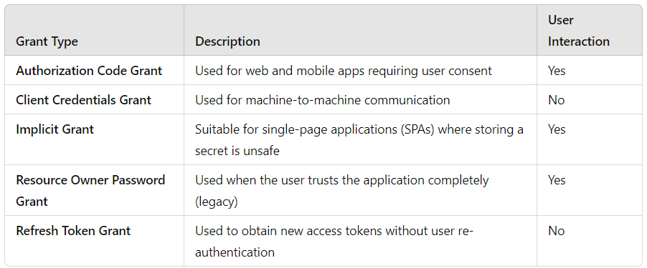
- Access Token:
  - A short-lived token that your application uses to access protected resources.
- Refresh Token:
  - A longer-lived token used to obtain new access tokens when the original expires.
- Scopes:
  - Permissions that define what level of access your application is requesting.
- Authorization Server:
  - The server that issues access tokens and handles authorization. (e.g., PayPal)
- Resource Server:
  - The server that holds the protected resources (e.g., user data, other resources) that your application wants to access. In this case, PayPal acts as the resource server.
- Client Application
  - The app that requests access to resources on behalf of the user, interacting with the Authorization and Resource Servers.

Authorization Code Grant
The Authorization Code Grant is secure and commonly used in applications that require user consent. Here's the step-by-step process:
- User Initiates the Process: The user clicks a "Sign In / Allow Access with <AuthorizationServer>" button on your app.
- Redirect to Authorization Server: The user is redirected to the authorization server (e.g., Google, PayPal) to log in and grant access to your application.
  - <body>
  - <h2>Login with Google</h2>
  - <button onclick="loginWithGoogle()">Sign In with Google</button>

  - <script>
  - function loginWithGoogle() {
  - const clientId = 'YOUR_GOOGLE_CLIENT_ID';
  - const redirectUri = 'http://localhost:8083/oauth2/callback';
  - const scope = 'openid email profile';
  - const responseType = 'code';
  - const authUrl = `https://accounts.google.com/o/oauth2/v2/auth?client_id=${clientId}&redirect_uri=${redirectUri}&response_type=${responseType}&scope=${scope}`;

  - // Redirect to Google login
  - window.location.href = authUrl;
  - }
  - </script>
  - </body>
- User Approves Access: The user logs in and grants permissions, such as "access my profile and email."
- Authorization Code Issued: The authorization server redirects the user back to your app’s URL with an authorization_code.
  - Eg: Google redirects back to http://localhost:8083/oauth2/callback?code=XYZ
- Exchange Code for Access Token: Your backend server sends a request to the authorization server with the authorization_code, client_id, client_secret, and redirect_uri to exchange it for an access_token.
- Access Protected Resources: With the access_token, your app can now access protected resources on behalf of the user.
Advantages:
- Secure since the client secret is never exposed to the frontend.
- Suitable for web and mobile applications.

Client Credentials Grant (Ideal for Server-to-Server Communication)

The Client Credentials Grant is used when there's no end-user involved, making it perfect for machine-to-machine (M2M) communication. Here’s the flow:
- Direct Request to Authorization Server: Your application sends a request to the authorization server with the client_id and client_secret.
- Access Token Issued: The server validates your credentials and issues an access_token.
- Access Protected Resources: Your application uses the access_token to access the resources.
Advantages:
- Simple and efficient for backend services.
- No user interaction required.

PayPal Using OAuth 2.0 with Client Credentials Grant
When integrating PayPal into our application, we use the Client Credentials Grant. In this scenario, there’s no user interaction—our backend application communicates with PayPal. Here’s how it works:
- Get Client ID and Secret:
  - We first create a PayPal app in our PayPal Developer Dashboard to get the client_id and client_secret.
- Get Access Token:
  - Our backend server exchanges the client_id and client_secret with PayPal’s OAuth API to obtain an access_token.
- Make API Calls:
  - With the access token, our backend server can make API calls to create payments, handle transactions, and more.

